# PROGRAMMING COMPETITION 2025

# CASE STUDY PROJECT FOR TERTIARY INSTITUTIONS

# 19 – 28 SEPT 2025

MEDICAL EXPERT SYSTEM FOR MALARIA AND TYPHOID FEVER (MESMTF) FOR MINISTRY OF HEALTH AND SOCIAL SERVICES

**GROUP MEMBERS OF ALT 4**

|  |  |
| --- | --- |
| **Name** | **Name of Institution** |
| Tinomuvongaishe T. Mpofu (TL) | NUST |
| Alicia EJ Sasamba | NUST |
| PJ-Amor N. Harakuta | NUST |
| Felicia P Hafenanye | NUST |
| Abraham Mabuta | NUST |

**TL =** Tinomuvongaishe T. Mpofu

**Submission Date:** 27/09/2025

**Git Link**: https://github.com/gitclxver/ALT4-MESMTF.git

**TABLE OF CONTENTS**

1. **DESCRIPTION OF PROJECT** ----------------------------------------- Page 3
2. **FUNCTIONALITIES PROVIDED BY THE SOFTWARE** ------------------- Page 3
3. **FLOWCHARTS AND/OR ALGORITHMS** --------------------------------- Page 4
4. **PROGRAMMING LANGUAGES/TOOLS USED** --------------------------- Page 5
5. **SOLUTION ARCHITECTURE** ----------------------------------------- Page 5
6. **SAMPLE SOURCE CODE SNIPPETS (MAX 2 PAGES)** ------------------- Page 7
7. **SAMPLE SOLUTION/SOFTWARE SCREENSHOTS (MAX 3 PAGES)** --------- Page 9
8. **CONCLUSION** --------------------------------------------------- Page 12

**1. DESCRIPTION OF PROJECT**

MESMTF is a web-based medical system that helps people diagnose malaria and typhoid fever using artificial intelligence. Think of it as having a doctor's assistant available 24/7 on your computer or phone.

The main idea is simple: when you're feeling sick with symptoms like headaches, fever, or stomach pain, you can enter these symptoms into our system. The AI then analyzes what you've entered and tells you if you might have malaria or typhoid fever. If the system thinks you're sick, it helps you book an appointment with a real doctor.

The system isn't just for patients though. Doctors can use it to manage their appointments and patient records. Nurses and pharmacists have their own sections too. Even hospital administrators can oversee everything from one central dashboard.

What makes it special is that, whether you're at home, work, or traveling, you can check your symptoms and get medical guidance. It's designed to make healthcare more accessible to everyone while helping medical professionals do their jobs better.

**2. FUNCTIONALITIES PROVIDED BY THE SOFTWARE**

**Core Functional Requirements:**

**User Management & Authentication:**

* Multi-role user registration (patients, doctors, nurses, pharmacists, administrators)
* Secure login system with username/password authentication
* Role-based access control with customized dashboards
* User profile management and account administration

**Medical Services:**

* Medical Records: Complete patient information management with upload/edit/delete/view/search capabilities
* Appointment Booking: Intelligent doctor search and appointment scheduling system with modification/cancellation options
* AI-Powered Diagnosis: Rule-based expert system for malaria and typhoid fever diagnosis using symptom analysis
* Treatment Planning: Comprehensive treatment recommendation system
* Pharmacy Services: Integrated pharmaceutical management
* Drug Administration: Medication management and tracking system
* Reporting: Prescription printing and comprehensive medical reports

**Expert System Features:**

* Symptom-based diagnosis using predefined medical rules
* Classification of symptoms into Very Strong Signs, Strong Signs , Weak Signs , and Very Weak Signs.
* Automated treatment recommendations
* Drug administration guidelines for different symptom severities

**Technical Capabilities:**

* Web-based responsive design compatible with PCs, laptops, and mobile devices
* Backend database integration
* Search functionality across doctors, drugs, and patient records
* Scalable architecture supporting multiple concurrent users

**Additional Features:**

* Dynamic system expansion capability for other diseases (TB, HIV/AIDS, Mental Health, Diabetes)
* Administrative dashboard for system management
* Secure data handling and patient privacy protection

**3. CORE FLOWCHARTS**

**Main User Journey (Primary Demo Flow)**

Landing Page → Role Selection → Login/Register → Role-Based Dashboard →

Patient: Symptom Checker → AI Diagnosis → Book Appointment

Doctor: View Patients → Review Diagnoses → Prescribe Treatment

Admin: User Management → System Reports → Generate PDFs

**AI Doctor Engine**

Start Symptom Checker → Select Symptoms from Checklist → Real-time Scoring →

Scoring Algorithm:

malaria_score = 0

typhoid_score = 0

For each selected symptom:

malaria_score += malaria_weights[symptom]

typhoid_score += typhoid_weights[symptom]

Diagnosis Logic:

if malaria_score > typhoid_score AND malaria_score >= 6:

diagnosis = "Malaria Likely"

confidence = malaria_score / max_possible_score

elif typhoid_score > malaria_score AND typhoid_score >= 6:

diagnosis = "Typhoid Likely"

confidence = typhoid_score / max_possible_score

elif both_scores >= 6:

diagnosis = "Co-infection Suspected"

else:

diagnosis = "Consult Doctor for Further Evaluation"

→ Display Results with Confidence Bars → Treatment Recommendations →

"Book Appointment" Button → End

**Appointment Booking Flow**

Patient Dashboard → "Book Appointment" → Search Available Doctors →

Filter by Specialty (Malaria/Typhoid Expert) → Select Time Slot →

Confirm Booking → Send Notification → Update Doctor's Calendar →

Store in Database → Confirmation Page

**Medical Records Management**

User Login → Check Role Permissions →

If Patient: View Own Records Only

If Doctor: View Assigned Patients + Add Diagnosis

If Admin: Full CRUD Access + Generate Reports

Actions:

Create → Validate Data → Generate Patient ID → Store

View → Apply Filters → Display List/Details

Search → Query Database → Return Results

Edit → Verify Permissions → Update → Log Changes

**Treatment & Pharmacy Workflow**

Doctor Reviews Diagnosis → Select Treatment Protocol →

Based on Symptom Severity:

VS Symptoms: Chest X-ray + Drug Administration

S/W/VW Symptoms: Drug Administration Only

Drug Selection:

if diagnosis == "Malaria": drugs = ["Artemether-Lumefantrine", "Quinine"]

if diagnosis == "Typhoid": drugs = ["Ciprofloxacin", "Azithromycin"]

if diagnosis == "Co-infection": drugs = [both_medications]

→ Generate Prescription → Mark as Administered → Update Patient Record

**4. PROGRAMMING LANGUAGES/TOOLS USED**

Frontend Technologies:

* React
* TypeScript
* Tailwind CSS

Backend/Database:

* Firebase

Development Environment:

* Visual Studio Code as the primary IDE

Additional Libraries:

* GitHub for version control and collaboration

**5. System Architecture Overview**

|  |
| --- |
| **Client Layer** |
| React frontend |
| Patient UI |
| Doctor UI |
| Admin UI |

|  |
| --- |
| **Service Layer** |
| Firebase APIs |
| Authentication |
| Real-Time DB |
| Cloud storage |

|  |
| --- |
| **Data Layer** |
| Cloud Firestore |
| User Data |
| Medical Data |
| Appointments |

⃗ ⃗ ⃗

**Component Architecture**

**Frontend Components:**

* Pages Layer: Landing, Dashboard, Authentication pages
* Components Layer: Reusable UI components (cards, forms, modals)
* Context Layer: Global state management for authentication and data
* Utils Layer: Helper functions, icons, and shared utilities

**Data Flow:**

1. User interaction triggers React component
2. Component calls Firebase service function
3. Firebase SDK communicates with cloud services
4. Real-time updates propagate back to all connected clients

**6. SAMPLE SOURCE CODE SNIPPETS**

**AI Diagnostic Engine Implementation**

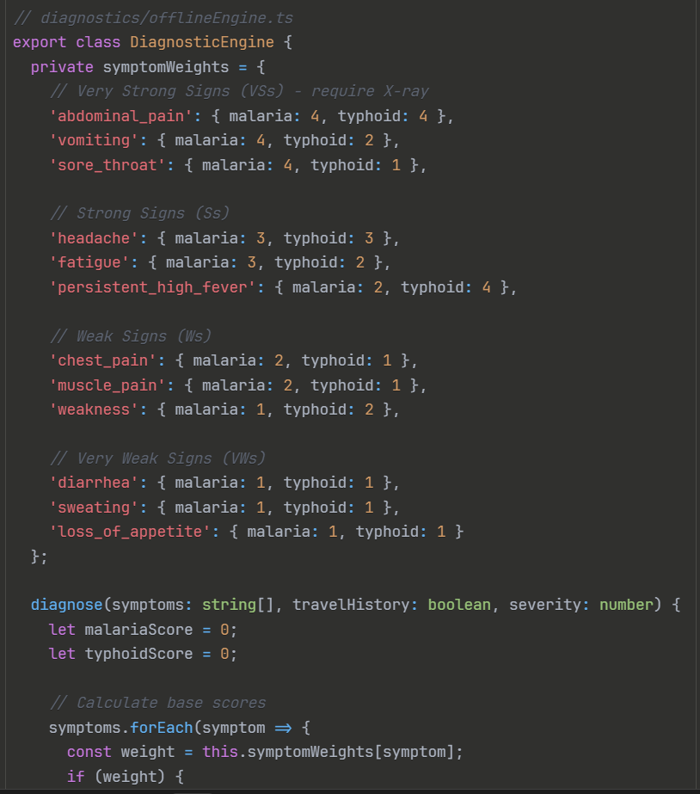

**Firebase Integration**

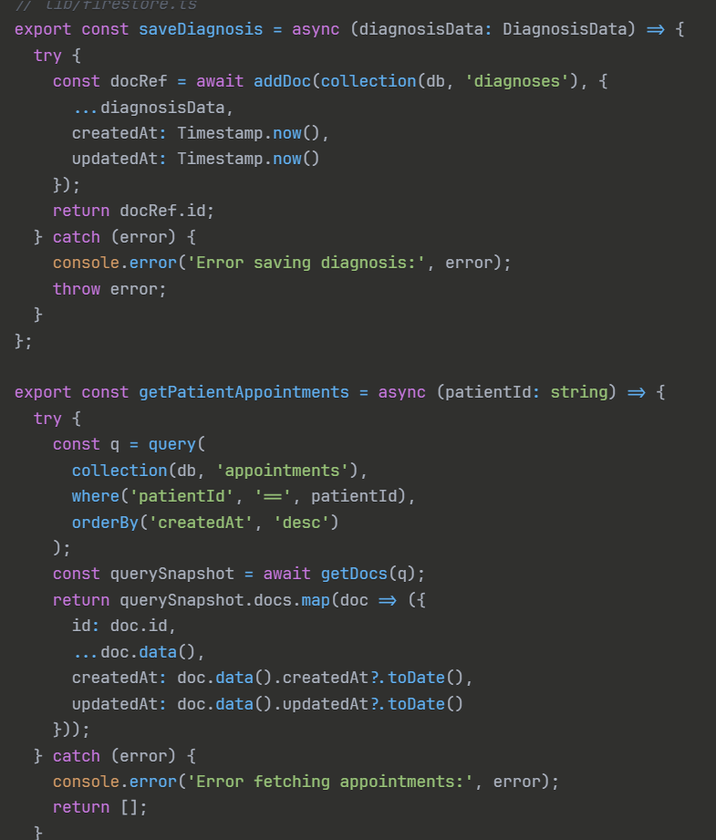

**7.Sample solution**

**Patient Dashboard**

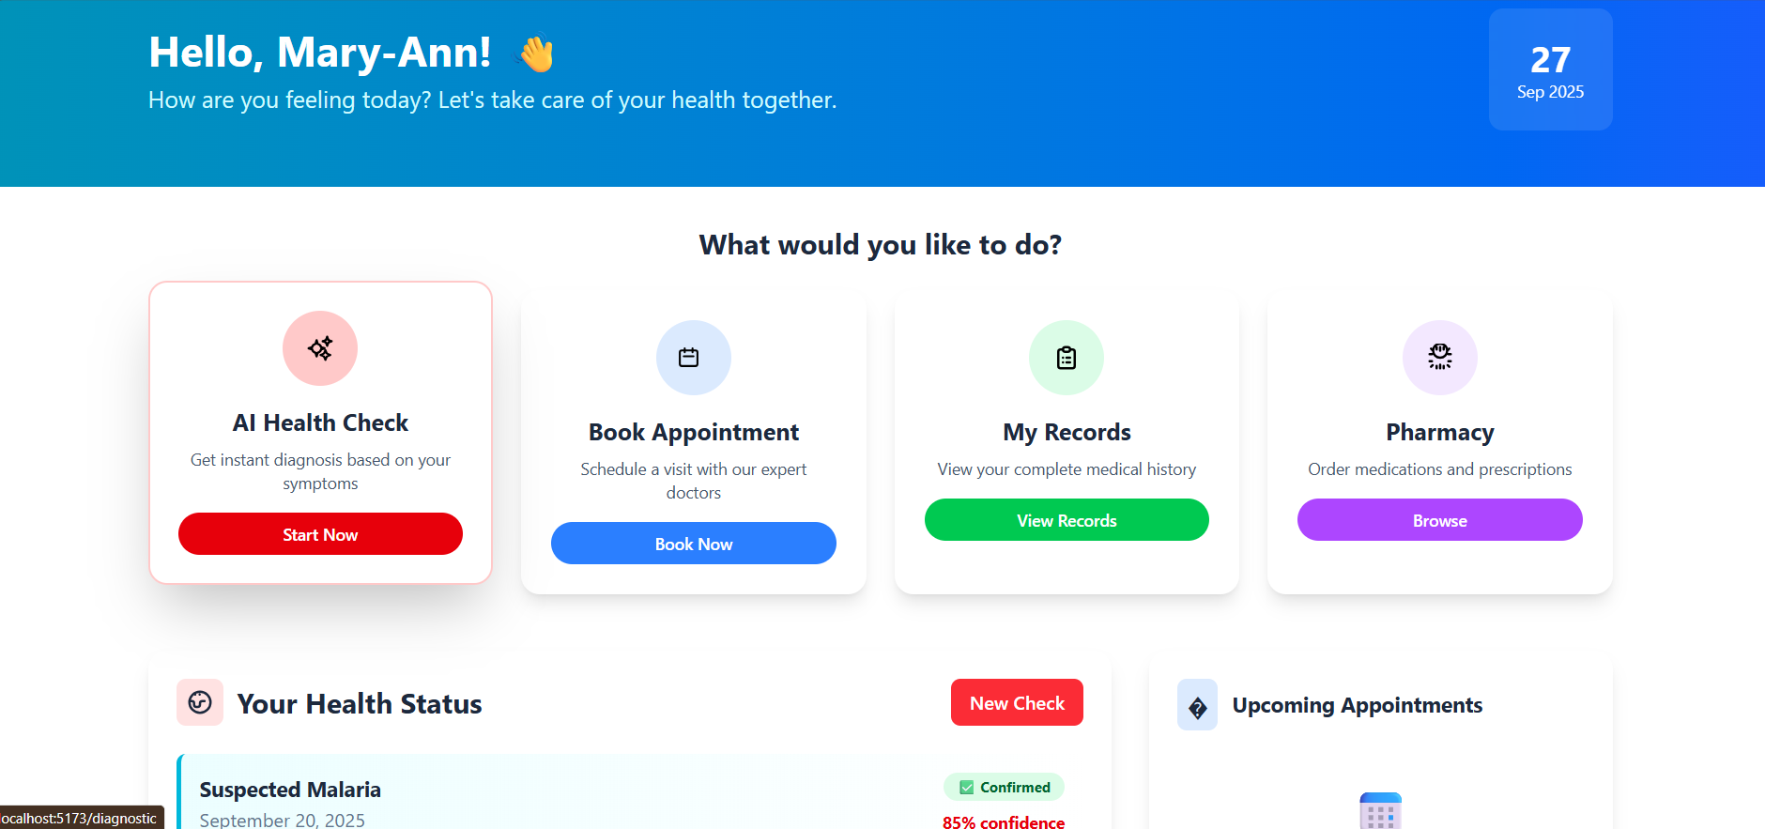

**Appointment Booking System**

**Medical Records Interface**

**Patient-Pharmacy Interface**

**Report Interface   
**

**Doctor Dashboard**

**Administor medication interface  
**

**8.CONCLUSION**

We've successfully built a smart, user-friendly medical system designed to tackle malaria and typhoid fever in Namibia. It not only meets all the competition's requirements but goes a step further by integrating helpful AI and automating key tasks to make healthcare more efficient.

**What Makes It Special?**

* It’s Comprehensive: We built every module that was asked for, from patient registration and appointment booking to AI-powered diagnosis and pharmacy management.
* It’s Smart & Safe: The AI diagnostic tool is a standout feature. It carefully analyzes symptoms and travel history, provides a confidence score for its assessment. Crucially, a doctor always gives the final approval.
* It’s Built for Real Life: The system is designed for everyone in the healthcare chain—patients, doctors, nurses, and pharmacists—each with their own tailored dashboard. It works on mobile phones and is ready to handle the demands of a real clinic.
* It’s Ready for the Future: Built with modern technology, the system is reliable, secure, and can easily be expanded in the future to include other diseases like tuberculosis or diabetes.

**The Bottom Line**

This system has the real potential to make a difference. It brings accurate, AI-assisted medical guidance to communities, supports healthcare workers, and is designed to work even in areas with poor internet connectivity. We're proud to have created a platform that is both technologically advanced and genuinely practical for the Ministry of Health and Social Services.